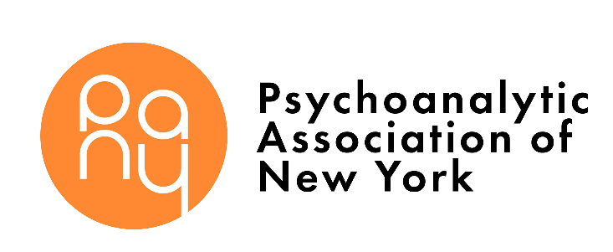
PRELUDE TO TRAINING ENROLLMENT FORM
(rev. 7/18/20) P: 646-754-4870
Email: pany@nyulangone.org
PERSONAL INFORMATION
Name: |  |  |  | Degree:
Date of Application:
HOME | Address: City/State/Zip:
 | Telephone: |  |  |  | Fax:
 | Email: |  |  |  | Cell:
PRIVATE OFFICE | Address: City/State/Zip:
 | Telephone: |  |  |  | Fax:
 | Email:
INSTITUTIONAL EMPLOYMENT | Address: City/State/Zip:
 | Telephone: |  |  |  | Fax:
 | Email:
Gender: |  | Date of Birth: |  |  |  | Citizenship:
Nondiscrimination Policy
PANY admits training candidates of any race, color, national and ethnic origin, actual or perceived sexual orientation, gender identity and gender expression to all the rights, privileges, programs, and activities generally accorded or made available to candidates at the Institute. PANY does not discriminate on the basis of race, color, national and ethnic origin, actual or perceived sexual orientation, gender identity or gender expression in
administration of its educational policies, admissions policies, and other institute-administered programs.
CURRICIULUM VITAE
Please attach your Curriculum Vitae to this application. Be sure to include:
- Current and recent professional activities
- Training (undergraduate, graduate, internships, externships, residencies, fellowships, and other postdoctoral training)
- Professional experience

REFERENCE – Please provide a clinical supervisor, professor, or colleague who can speak briefly to us about you. Please note that they will only be contacted if more information is needed.
Name: |  |  | Degree:
Address: City/State/Zip:
Telephone: |  | Fax:
Email:
How did you first hear of the Institute at PANY?
Have you been to any of our events? If so, please list.
Please tell us about your interest in participating in the Prelude to Training Program.
I understand that the electronic submission by email is equivalent to my signature.

Signature: Date:

How to submit registration and payment:

- Online:
  - Complete online enrollment form and payment at

  - Or Email this completed form and curriculum vitae to pany@nyulangone.org or fax to 646-754-9540.
- To make $320 deposit payment, use PAYPAL or ZELLE PAYMENTS, SEND TO pany@nyulangone.org

- By mail: N/A
  - Please note during this time period we are not accepting mailed enrollment forms or payment

- If you do not receive a phone call or email that we received your enrollment form within 2 weeks of submission, please contact PANY at 646-754-4870.

- The balance of $250 is due on November 15.

