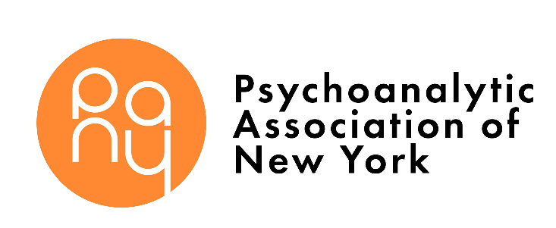
PSYCHOTHERAPY FOR PSYCHOSIS COURSE ENROLLMENT FORM
(rev. 9/12/19) P: 646-754-4870
Email: pany@nyulangone.org
PERSONAL INFORMATION
Name: |  |  |  | Degree:
Date of Application:
HOME | Address: City/State/Zip:
 | Telephone: |  |  |  | Fax:
 | Email: |  |  |  | Cell:
PRIVATE OFFICE | Address: City/State/Zip:
 | Telephone: |  |  |  | Fax:
 | Email:
INSTITUTIONAL EMPLOYMENT | Address: City/State/Zip:
 | Telephone: |  |  |  | Fax:
 | Email:
Gender: |  | Date of Birth: |  |  |  | Citizenship:
Nondiscrimination Policy
PANY admits training candidates of any race, color, national and ethnic origin, actual or perceived sexual orientation, gender identity and gender expression to all the rights, privileges, programs, and activities generally accorded or made available to candidates at the Institute. PANY does not discriminate on the basis of race, color, national and ethnic origin, actual or perceived sexual orientation, gender identity or gender expression in
administration of its educational policies, admissions policies, and other institute-administered programs.
CURRICIULUM VITAE
Please attach your Curriculum Vitae to this application. Be sure to include:
- Current and recent professional activities
- Training (undergraduate, graduate, internships, externships, residencies, fellowships, and other postdoctoral training)
- Professional experience

REFERENCE – Please provide a clinical supervisor, professor, or colleague who can speak briefly to us about you.
Name: |  |  | Degree:
Address: City/State/Zip:
Telephone: |  | Fax:
Email:
How did you first hear of PANY?
Have you been to any of our events? If so, please list.
Please tell us about your interest in participating in the Psychotherapy for Psychosis Course
I understand that the electronic submission by email is equivalent to my signature.

Signature: Date:

How to enroll and submit payment:

  - Email your form and curriculum vitae to pany@nyulangone.org or fax to 646-754-9540.

- Submit $400 course or $850 course/group payment by going to
www.pany.org/course-application and using Paypal links for Paypal or credit card payment.

- For Zelle payments, send to pany@nyulangone.org

- Payments by mail:
  - Make payable to “Psychoanalytic Association of New York” and mail to:

Psychoanalytic Association of New York
NYU Department of Psychiatry
One Park Avenue, 8th Floor New York, NY 10016
ATTN: PSYCHOANALYTIC

- If you do not receive a phone call or email that we received your application within 2 weeks of submission, please contact PANY at 646-754-4870.

Thank you!

