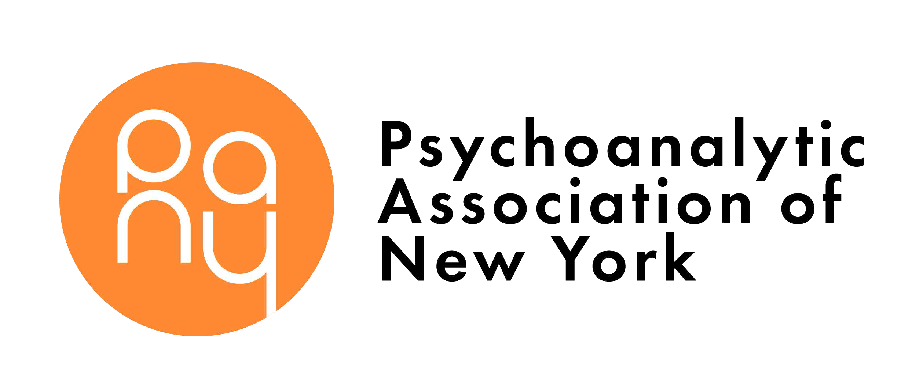
Referral for Supervision

www.pany.org | pany@nyulangone.org
We welcome your interest in Psychoanalytic Association of New York’s Supervisory Program. After completion of this application you will be contacted by PANY’s Supervisory Coordinator for a brief discussion of your interests and needs. PANY offers both individual and group supervision with faculty members who are practicing psychoanalysts. We will make every effort to match you with a group or individual appropriate to your particular interests and needs.

Private supervision is offered to individuals who seek further education in the technique of psychoanalytic psychotherapy. This service is made available only to psychotherapists whose license permits them to work independently. Please submit a copy of your license, professional liability insurance and your curriculum vitae with this application. There is no application fee.
PERSONAL INFORMATION
Date of Application:
First Name: |  |  |  | Last Name:
Degree/License:
HOME | Address:  City/State/Zip:
 | Telephone:
 | Email: |  |  |  | Cell:
PRIVATE OFFICE | Address:  City/State/Zip:
 | Telephone: Email:
INSTITUTIONAL EMPLOYMENT | Name and  location of Employer
 | Telephone: Email:
Gender: |  | Date of Birth: |  |  |  | Citizenship:

SUPERVISION
I am interested in / / private supervision / /group supervision (check one or both)
YOUR AVAILABILITY
 |  | Monday | Tuesday | Wednesday | Thursday | Friday
 | Morning
 | Afternoon
 | Evening
Comments:
Please indicate your preferred location:
Manhattan neighborhoods: Brooklyn neighborhoods:
Comments:
Please tell us a bit about what you hope to achieve in a supervisory relationship:

Please describe your practice:
DISCLAIMER:
I understand and acknowledge that if I am selected to participate in the Psychoanalytic Association of New York (PANY) Supervisory Referral Service, PANY will refer me to a practicing psychoanalyst for educational consultations regarding the practice of psychotherapy. These consultations are designed to supplement my professional education and will not be used to meet any clinical requirements pertaining to my license. I understand and acknowledge that any discussion of my clinical work is for educational purposes only and not for guidance on my treatment of individual patients. I understand that neither PANY, its faculty, nor any individuals involved in this program have any responsibility whatsoever for my patients or clients. I understand that PANY is not providing clinical supervision. I am responsible for maintaining the confidentiality of any patient or client information discussed during the consultation process in addition to obtaining any patient or client consents pursuant to the requirements of my license or applicable law. I agree that I will not represent myself as being affiliated with or enrolled in any training program administered or operated by PANY will make every effort to refer me to individual or group supervision according to the preferences I have indicated on my application (geographic location, time availability, etc.). However, I understand that my application does not guarantee placement with an individual or group. Once referred, I understand that the supervisor, not PANY, is responsible for the content and duration of the supervisory relationship.
Electronic submission by email is equivalent to my signature.
Please type in your signature and date below.

Signature: Date:
CURRICULUM VITAE , LICENSE AND MALPRACTICE INSURANCE
Please attach your curriculum vitae and a copy of your license and malpractice insurance
to this application. You may submit this by email, to pany@nyulangone.org, or mail to: Psychoanalytic Association of New York, c/o Institute for Psychoanalytic Education, 1 Park Avenue, 8th Floor, New York, NY 10016. Call the PANY office with any questions: 646-754-4870.

